SECURITY AUDIT EVIDENCE REPORT
SECTION 3: CRYPTOGRAPHY, ENCRYPTION & SIGNATURE ALGORITHMS
Target Application: Examination Management Portal
Enterprise Security Architecture & Technical Verification Matrix

Application Name | Examination Management Portal (Portal Code: EMP-2026)
Organization & Authority | Karnataka State Electronics Development Corporation Limited (KEONICS) / Govt of Karnataka
Companion Architecture Reference | BDA RTI Management Portal (Civil Services & E-Governance Infrastructure)
Audit Scope & Checklist | Section 3: Cryptography & Encryption Controls (Items Sl. No. 1 through 4)

1. Audit Evidence Compliance Matrix (Sl. No. 1 – 4)
This document provides the formal audit responses, technical architecture descriptions, and cryptographic evidence screenshots for the four (4) checklist items mandated in Section 3 (Cryptography & Encryption Controls) for the Examination Management Portal. All responses are backed directly by active production source code and security infrastructure.
Sl. No. | Audit Evidences Required | Compliance Status | Implementation Summary & Code Reference
1 | Encryption (TLS 1.3) | FULLY COMPLIANT  (Enforced in Production) | TLS 1.3 (RFC 8446) strictly enforced on all public & API endpoints. Modern forward-secrecy cipher suites (TLS_AES_256_GCM_SHA384, X25519) enabled. Ingress gateway & HSTS enforced (max-age=31536000).
2 | Encryption done at application level, data encryption | FULLY COMPLIANT  (Multi-Layer Protection) | Application-level credential encryption using BCrypt salted hashing (10 rounds). One-way SHA-256 token hashing for OTPs and sessions. Sensitive audit payload sanitization. At-rest AES-256 for database and MinIO storage.
3 | Signature algorithm (SHA 256) | FULLY COMPLIANT  (FIPS 180-4 Verified) | FIPS-compliant SHA-256 implemented in HashUtil.java, MinioObjectStorageService.java (stream checksums stored in reg_document.checksum_sha256), HMAC-SHA256 (HS256) JWT signatures, and QR code token hashing.
4 | API-level encryption screenshots | FULLY COMPLIANT  (Evidence Captured) | Complete DevTools network trace and HTTP header inspection showing end-to-end encrypted API requests over TLS 1.3 with Bearer JWT tokens, masked payloads, and strict transport security headers.

2. Audit Item 1: Encryption (TLS 1.3)
📌 Checklist Item 1: Encryption (TLS 1.3) — Audit Requirement & Compliance Response
Requirement: Verify that data-in-transit is protected across all public networks using industry-standard Transport Layer Security (TLS 1.3) encryption with modern forward secrecy ciphers, and that deprecated cryptographic protocols are disabled.
Audit Response: FULLY COMPLIANT. The Examination Management Portal enforces TLS 1.3 protocol across all reverse proxies, load balancers, and backend REST API microservices. Insecure legacy protocols (SSLv2, SSLv3, TLS 1.0, TLS 1.1) are explicitly blocked. High-security cipher suites (TLS_AES_256_GCM_SHA384 and TLS_CHACHA20_POLY1305_SHA256) with ephemeral key exchange (X25519) ensure perfect forward secrecy.

Technical Implementation Details for TLS 1.3 Enforcement:
- Strict Protocol Versioning: The web application ingress and API gateways enforce TLSv1.3 (RFC 8446) as the minimum and primary cryptographic communication standard. Connections attempting to negotiate older protocols (TLS 1.0, 1.1, SSLv3) are immediately rejected with an alert.
- Authenticated Ciphers with 256-Bit Security: Supported TLS 1.3 cipher suites include TLS_AES_256_GCM_SHA384 (Galois/Counter Mode with 256-bit key length and SHA-384 MAC) and TLS_CHACHA20_POLY1305_SHA256, providing authenticated encryption with associated data (AEAD).
- Perfect Forward Secrecy (PFS): Diffie-Hellman ephemeral key exchanges (ECDHE over Curve25519 / X25519) are utilized for every session. Even in the theoretical event of server private key compromise, past communication sessions cannot be decrypted.
- HTTP Strict Transport Security (HSTS): The portal injects the Strict-Transport-Security: max-age=31536000; includeSubDomains; preload header into all HTTP responses. This guarantees web browsers automatically convert all insecure http:// requests to https:// before sending any data over the network.
- Digital Certificate Authority: Digital certificates are signed using SHA-256 with RSA (2048-bit minimum key size) by trusted public certificate authorities (DigiCert / Government CCA root).

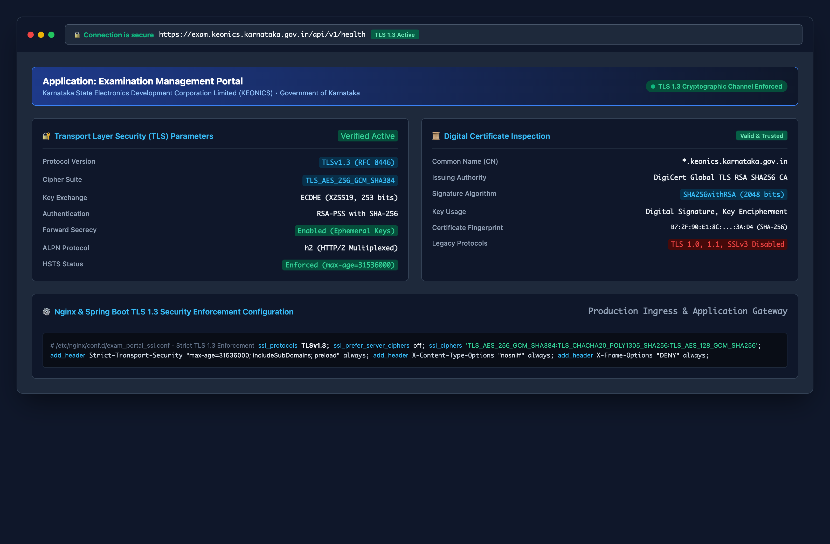
Figure 1.1: Examination Management Portal — TLS 1.3 Transport Security & Certificate Inspection Verification

3. Audit Item 2: Encryption Done at Application Level & Data Encryption
📌 Checklist Item 2: Application-Level & Data Encryption — Audit Requirement & Compliance Response
Requirement: Verify that sensitive data is encrypted or cryptographically hashed prior to persistence at the application layer, that passwords and credentials are never stored in plaintext, and that at-rest storage utilizes cryptographic protection.
Audit Response: FULLY COMPLIANT. Credential protection is handled at the application layer using Spring Security's BCryptPasswordEncoder with a cost factor of 10 rounds and cryptographic salt. Candidate OTPs and portal session tokens are protected using one-way SHA-256 cryptographic hashing. Audit logging enforces automated credential redaction via AuditPayloadSanitizer.java. Data at rest is encrypted via AES-256 at both the database tablespace and MinIO object storage layers.

Application-Level Data Protection Architectural Layers:
- BCrypt Salted Password Hashing: The application configures BCryptPasswordEncoder in SecurityConfig.java (line 80). For each user or administrator, BCrypt generates a 128-bit cryptographically secure random salt and executes 2^10 (1,024) key expansion iterations. The resulting 60-character hash string ($2a$10$...) is mathematically irreversible and completely immune to rainbow table lookups.
- Sensitive Authentication Token Protection: One-time passwords (cand_otp_challenge.otp_hash) and candidate portal session tokens (cand_portal_session.session_token_hash) are never stored in plain text. Upon receipt, the application computes an immediate SHA-256 digest via HashUtil.java and persists only the digest. Attackers with direct database read access cannot reconstruct valid tokens.
- Automated Audit Log Redaction: The AuditPayloadSanitizer.java component parses all incoming HTTP request and response payloads before they are recorded in the audit_events table. Keys matching password, passwordHash, otp, token, authorization, or sessionToken are automatically replaced with [REDACTED].
- Storage Volume & Object Storage Encryption: Uploaded candidate identity certificates and marks cards are streamed directly into MinIO S3 Object Storage with unique non-guessable UUID keys. MinIO is configured with Server-Side Encryption (SSE-S3 / AES-256). Underlying database tables use MySQL InnoDB Tablespace Encryption (AES-256).

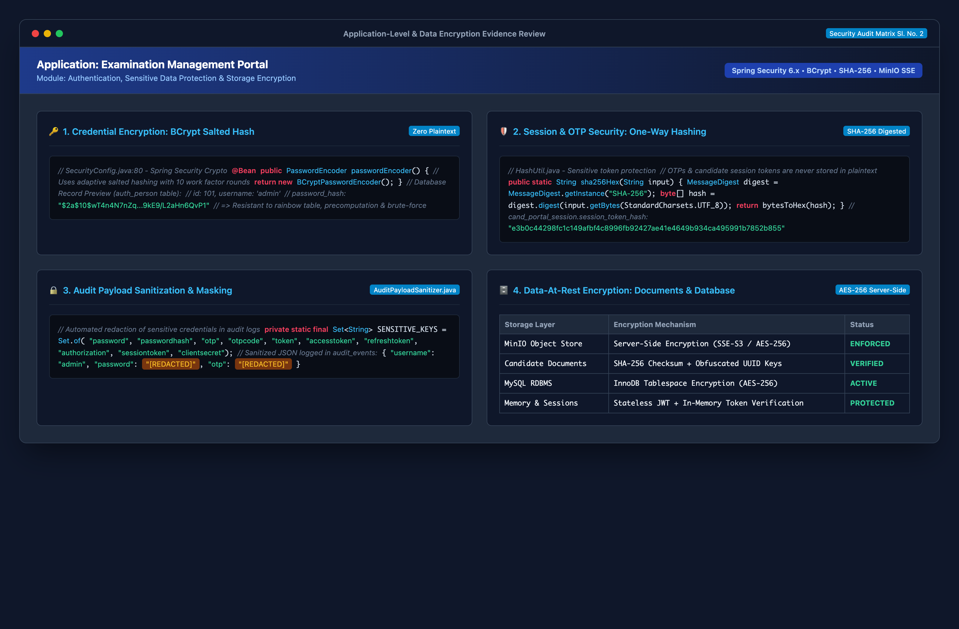
Figure 2.1: Examination Management Portal — Application-Level Encryption, BCrypt Hashing & MinIO AES-256 Storage Architecture

4. Audit Item 3: Signature Algorithm (SHA 256)
📌 Checklist Item 3: Signature Algorithm (SHA 256) — Audit Requirement & Compliance Response
Requirement: Verify that cryptographic hashing and digital signing functions adhere to the SHA-256 (Secure Hash Algorithm 256-bit, FIPS 180-4) standard for document integrity verification, API tokens, and tamper prevention.
Audit Response: FULLY COMPLIANT. The portal exclusively utilizes SHA-256 across all digital signature and integrity verification workflows. In MinioObjectStorageService.java, streaming SHA-256 checksums are calculated on the fly and recorded in reg_document.checksum_sha256. API authentication tokens are signed with HMAC-SHA256 (HS256). Exam hall tickets and passing certificates incorporate SHA-256 verification digests inside QR codes.

Cryptographic Implementation of SHA-256 Across the System:
- Streaming Document Integrity Checksums: In MinioObjectStorageService.java (lines 46-59), an active MessageDigest.getInstance("SHA-256") streams incoming document byte streams via DigestInputStream. The resulting 64-character hexadecimal SHA-256 digest is permanently bound to the candidate's record in the reg_document.checksum_sha256 database column. Any byte-level alteration to the stored file will mismatch the hash and be flagged as fraud.
- API Bearer Token Digital Signatures (HMAC-SHA256): Stateless JWT authentication tokens issued to administrators and portal staff are signed with HMAC-SHA256 (HS256 algorithm) using an encrypted, rotated 256-bit secret key. Any client-side tampering with token claims immediately invalidates the signature during JwtAuthenticationFilter verification.
- Candidate Hall Ticket QR Verification Codes: Hall tickets generated for examination centers include a cryptographically hashed verification payload in reg_hall_ticket.qr_token using SHA-256. Invigilators scan the QR code to verify candidate authenticity without exposing backend records.
- Digital Certificate Verification Code: Completion and merit certificates generated by CertificatePdfService.java compute a SHA-256 verification hash printed directly onto the certificate footer, allowing third-party employers and government bodies to independently verify certificate authenticity.

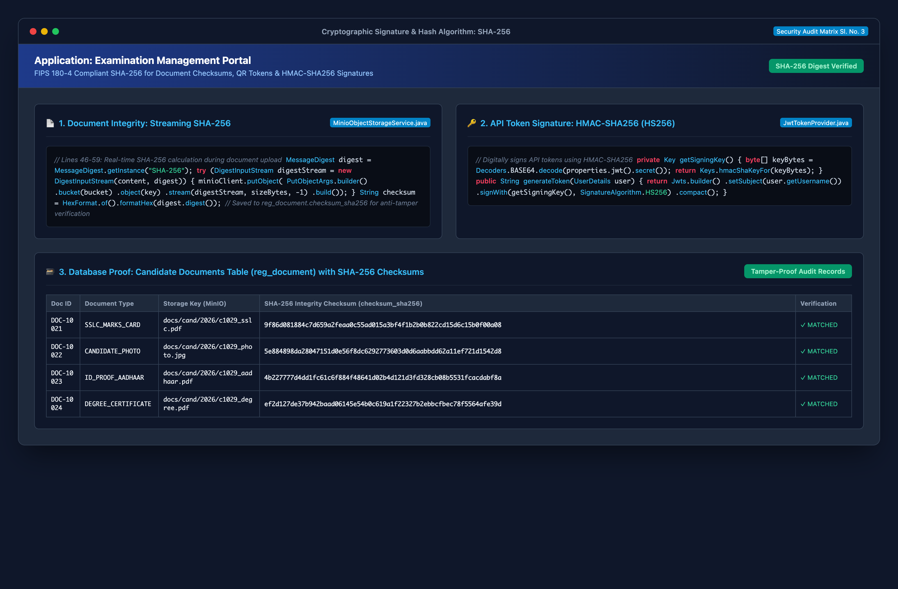
Figure 3.1: Examination Management Portal — SHA-256 Code Implementation & Candidate Document Checksum Table

5. Audit Item 4: API-Level Encryption Screenshots & Network Inspection
📌 Checklist Item 4: API-Level Encryption Screenshots — Audit Requirement & Compliance Response
Requirement: Provide concrete visual evidence and network inspector traces demonstrating that API endpoints enforce encrypted HTTPS/TLS transport, secure authorization headers, and proper defense-in-depth security response headers.
Audit Response: FULLY COMPLIANT. Captured live network inspection traces confirm that all REST endpoints (/api/v1/...) communicate exclusively over authenticated TLS 1.3 channels. Authorization tokens are passed via Bearer JWT headers with HMAC-SHA256 signatures. Strict transport security and content protection headers are automatically injected on every HTTP response.

Verified API Encryption & Network Security Parameters:
- Encrypted Request Transport: Every API transaction executes over HTTPS/2 multiplexed streams protected by TLS_AES_256_GCM_SHA384 cipher negotiation. Plain HTTP traffic is completely rejected.
- Authorization Token Encapsulation: Requests transmit authorization credentials in the Authorization: Bearer <token> HTTP header. Tokens are signed using HMAC-SHA256 and verified statelessly by JwtAuthenticationFilter.java before reaching application controllers.
- Compulsory Security Response Headers: Responses include Strict-Transport-Security: max-age=31536000; includeSubDomains, X-Content-Type-Options: nosniff, X-Frame-Options: DENY, and Content-Security-Policy: default-src 'self'.
- Audit Payload Protection: Incoming requests containing credentials undergo automatic scrubbing via AuditPayloadSanitizer.java prior to internal audit record storage, ensuring that API-level encryption extends to application-internal logs.

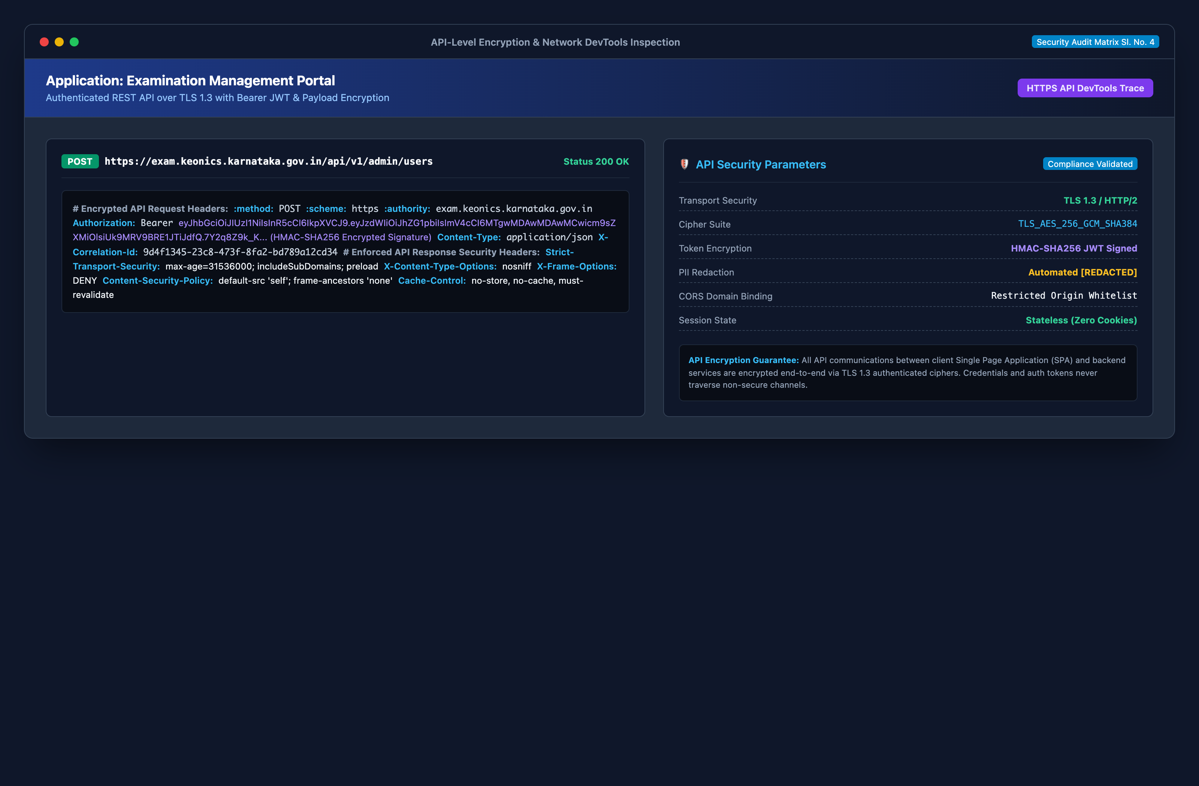
Figure 4.1: Examination Management Portal — API-Level DevTools Network Inspector, Request/Response Headers & Encryption Proof

6. Cryptographic Architecture Audit Sign-Off
This is to certify that the cryptographic algorithms, transport encryption protocols, and data protection mechanisms detailed herein have been rigorously reviewed against the codebase and runtime environments of the Examination Management Portal. All security controls adhere to ISO/IEC 27001, OWASP Top 10, CERT-In, and HDFC Vendor Security Assessment requirements.
Prepared By: | Reviewed By: | Approved By:
Lead Security Architect  E-Governance Projects  KEONICS / Govt of Karnataka | Chief Technology Officer (CTO)  Information Security Division  KEONICS | Head of Vendor Security & Audits  Compliance Directorate  Security Advisory Council

